Buổi 2 (20/8/2025)

Web front-end (4) - HTML_Tạo một trang web đơn giản

Bài tập và thực hành
(Không nên sử dụng google để dịch các bài tập bằng tiếng Anh, mà nên dùng từ điển để tự dịch và làm theo. Mục đích để rèn khả năng đọc hiểu tài liệu tiếng Anh).
Bài tập 1. Viết lại các đoạn mã trong phần lý thuyết.
Bước 1: Nhập nội dung trong chương trình Notepad
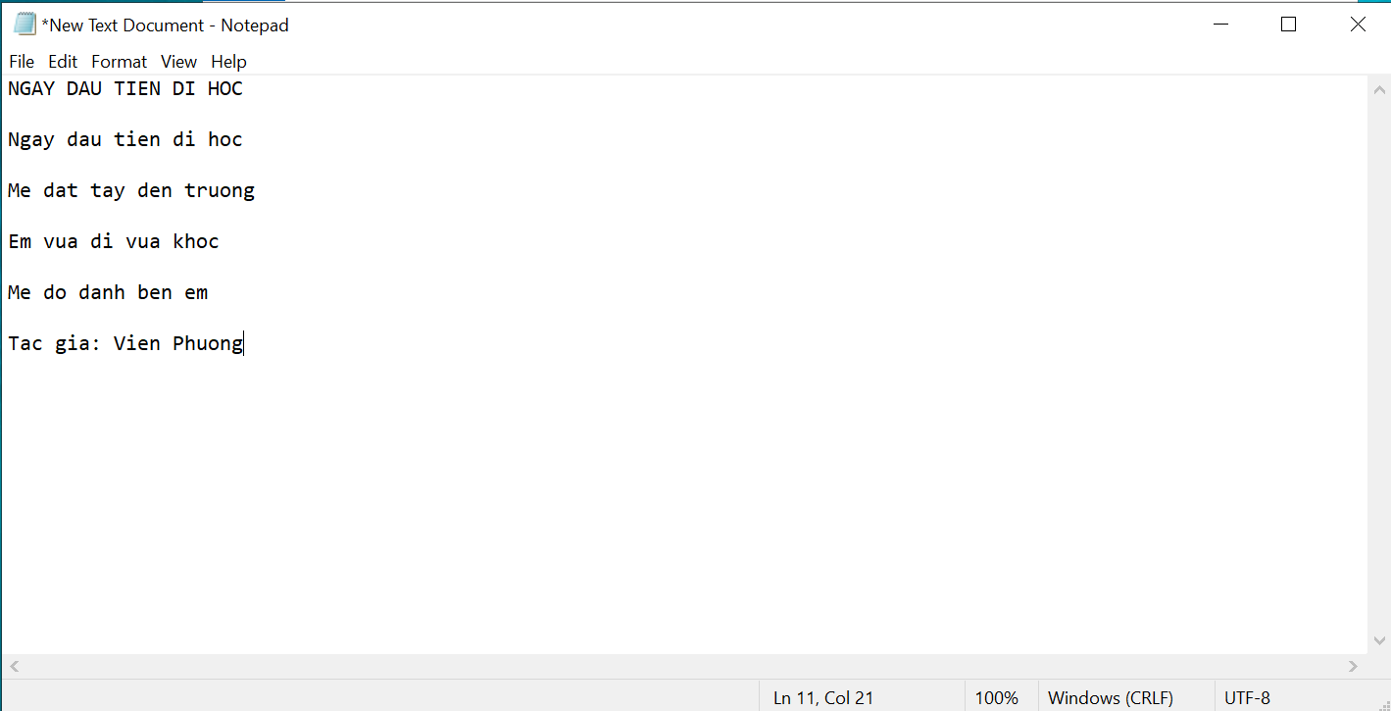
Bước 2: Lưu nó dưới dạng index.html
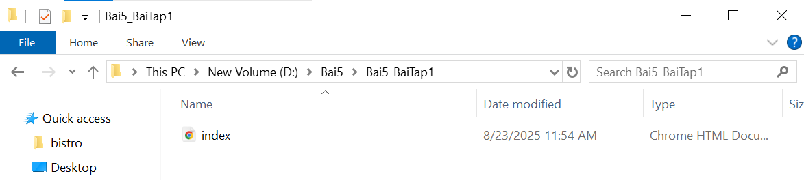
[Kết quả khi đúp chuột vào index.html]
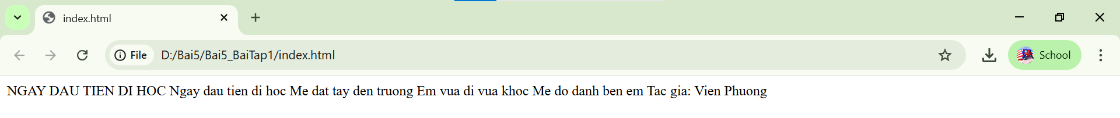
Bước 3: Tạo cấu trúc HTML cho phần nội dung
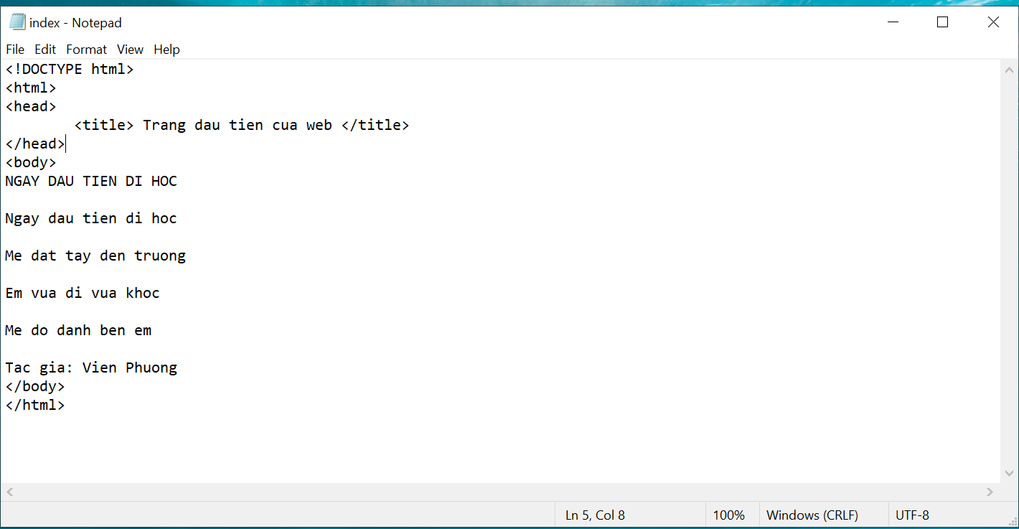
Bước 4: Thêm tên thẻ cần đặt cho phần nội dung
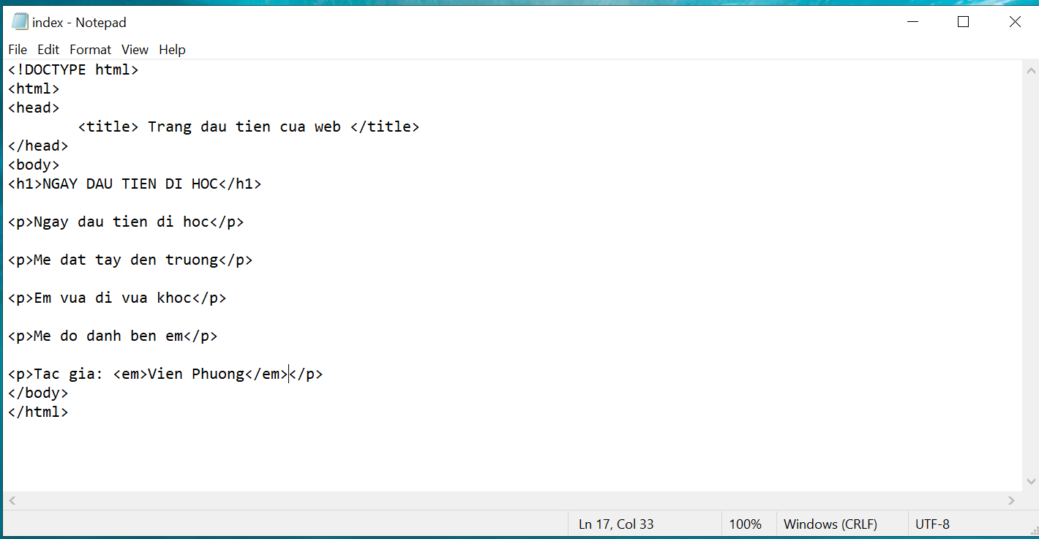

[Kết quả]
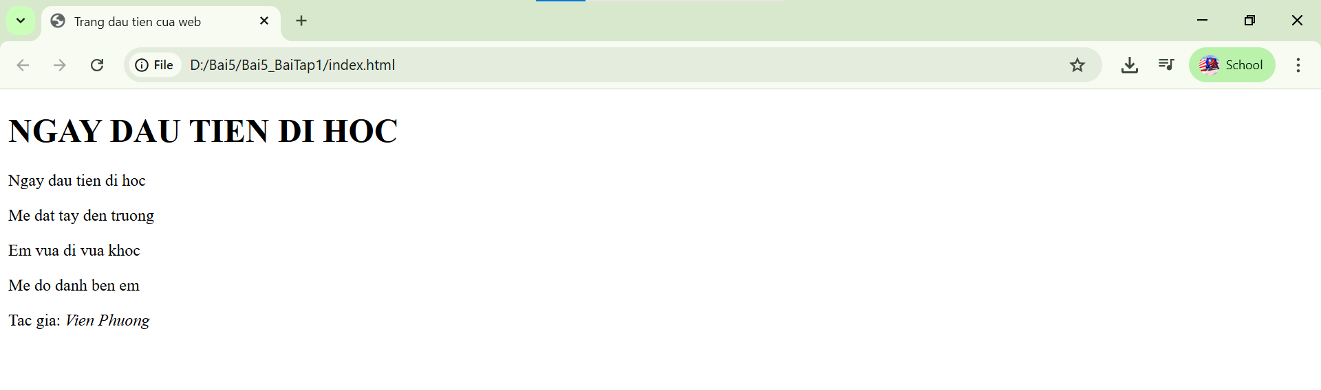
Bài tập 2. Entering content
1. Type the home page content below into the new document in your text editor (e.g Notepad). Copy it exactly as you see it here, keeping the line breaks the same.
Black Goose Bistro

The Restaurant
The Black Goose Bistro offers casual lunch and dinner fare in a relaxed atmosphere. The menu changes regularly to highlight the freshest local ingredients.

Catering
You have fun. We'll handle the cooking. Black Goose Catering can handle events from snacks for a meetup to elegant corporate fundraisers.

Location and Hours
Seekonk, Massachusetts;
Monday through Thursday 11am to 9pm; Friday and Saturday, 11am to
midnight
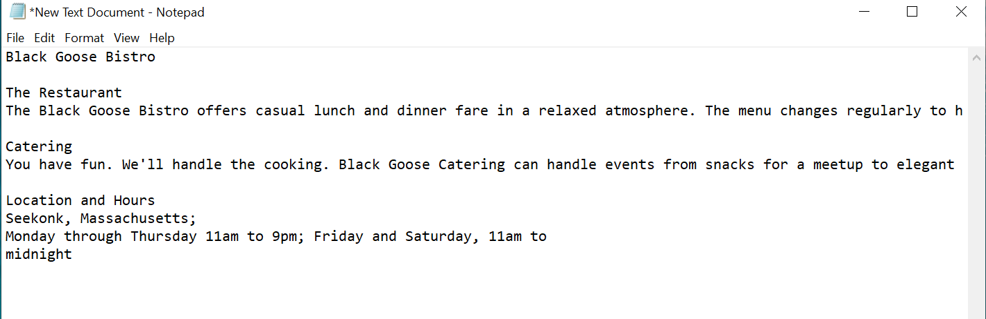
2. Select “Save” or “Save as” from the File menu of text editor to save document into harddisk. The first thing you need to do is create a new folder that will contain all of the files for the site. The technical name for the folder that contains everything is the local root directory. Name the new folder bistro, and save the text file as index.html in it. The filename needs to end in .html to be recognized by the browser as a web document.
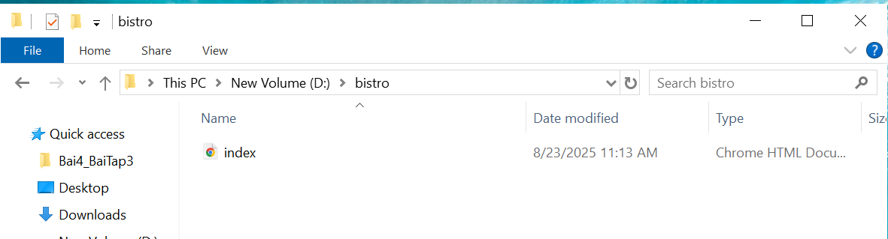
3. Let’s take a look at index.html in a browser. Double-click the filename in the File Explorer to launch your default browser, or right-click the file for the option to open it in the browser of your choice.
4. You should see some text on the screen.
[Result]
Black Goose Bistro The Restaurant The Black Goose Bistro offers casual lunch and dinner fare in a relaxed atmosphere. The menu changes regularly to highlight the freshest local ingredients. Catering You have fun. We'll handle the cooking. Black Goose Catering can handle events from snacks for a meetup to elegant corporate fundraisers. Location and Hours Seekonk, Massachusetts; Monday through Thursday 11am to 9pm; Friday and Saturday, 11am to midnight
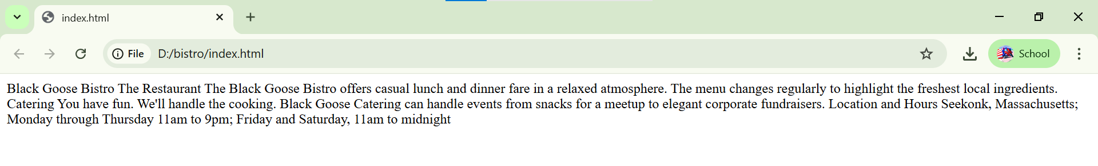
Bài tập 3. Adding minimal structure
1. Open the new index.html document if it isn’t open already and add the DOCTYPE declaration:
<!DOCTYPE html>
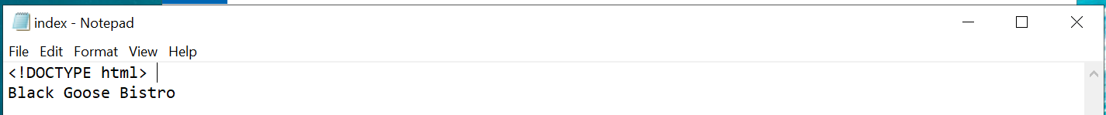
2. Put the entire document in an HTML root element by adding an <html> start tag after the DOCTYPE and an </html> end tag at the very end of the text.
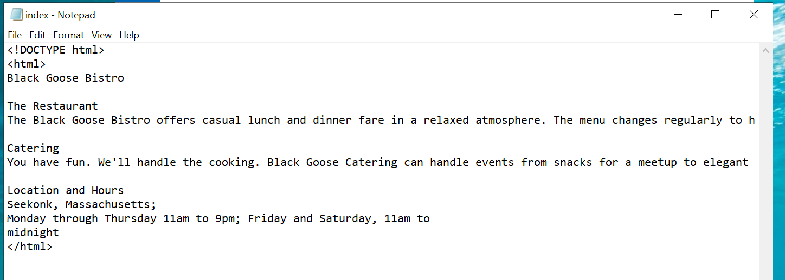
3. Next, create the document head that contains the title for the page. Insert <head> and </head> tags before the content. Within the head element, add information about the character encoding <meta charset="utf-8">, and the title, “Black Goose Bistro”, surrounded by opening and closing <title> tags.
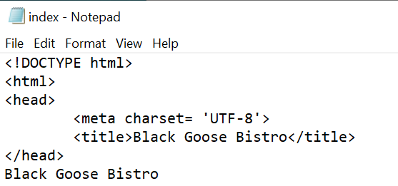
4. Finally, define the body of the document by wrapping the text content in <body> and </body> tags. When you are done, the source document should look like this (the markup is shown in color to make it stand out):

<!DOCTYPE html>
<html>
<head>
<meta charset="utf-8">
<title>Black Goose Bistro</title>
</head>
<body>
Black Goose Bistro
The Restaurant
The Black Goose Bistro offers casual lunch and dinner fare in a relaxed atmosphere. The menu changes regularly to highlight the freshest local ingredients.

Catering
You have fun. We'll handle the cooking. Black Goose Catering can handle events from snacks for a meetup to elegant corporate fundraisers.

Location and Hours
Seekonk, Massachusetts;
Monday through Thursday 11am to 9pm; Friday and
Saturday, 11am to midnight
</body>
</html>
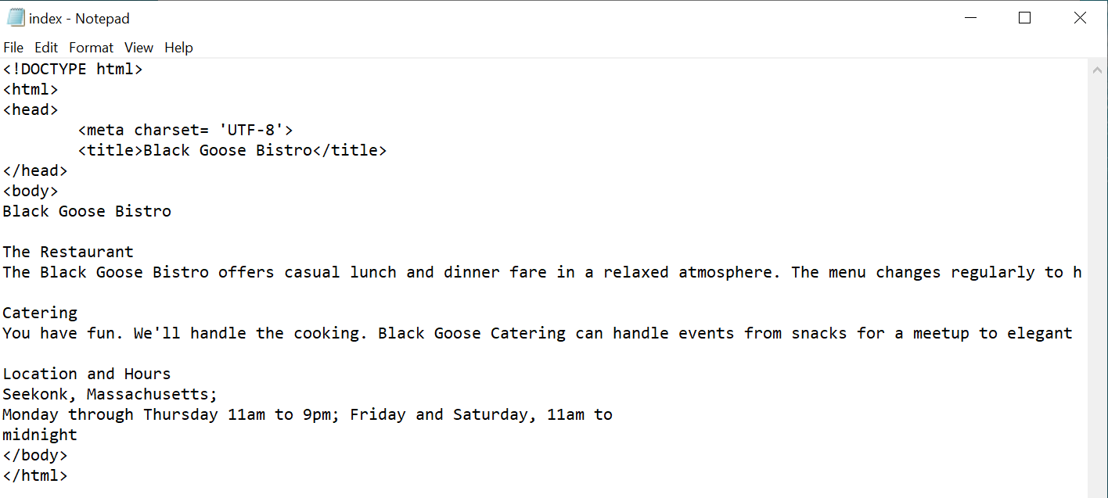
5. Save the document in the bistro directory, so that it overwrites the old version. Open the file in the browser or hit Refresh or Reload if it is open already.
[Result]
Black Goose Bistro The Restaurant The Black Goose Bistro offers casual lunch and dinner fare in a relaxed atmosphere. The menu changes regularly to highlight the freshest local ingredients. Catering You have fun. We'll handle the cooking. Black Goose Catering can handle events from snacks for a meetup to elegant corporate fundraisers. Location and Hours Seekonk, Massachusetts; Monday through Thursday 11am to 9pm; Friday and Saturday, 11am to midnight
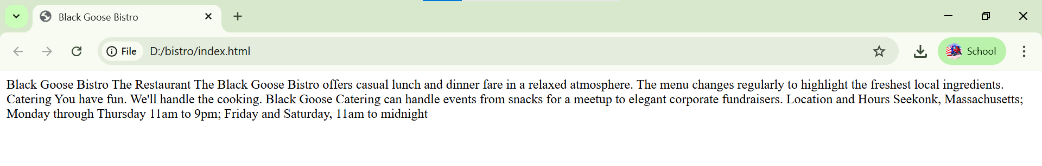
Bài tập 4. Defining text elements
1. Open the document index.html in your text editor, if it isn’t open already.
2. The first line of text, “Black Goose Bistro,” is the main heading for the page, so we’ll mark it up as a Heading Level 1 (h1) element. Put the opening tag, <h1>, at the beginning of the line and the closing tag, </h1>, after it, like this:
<h1>Black Goose Bistro</h1>
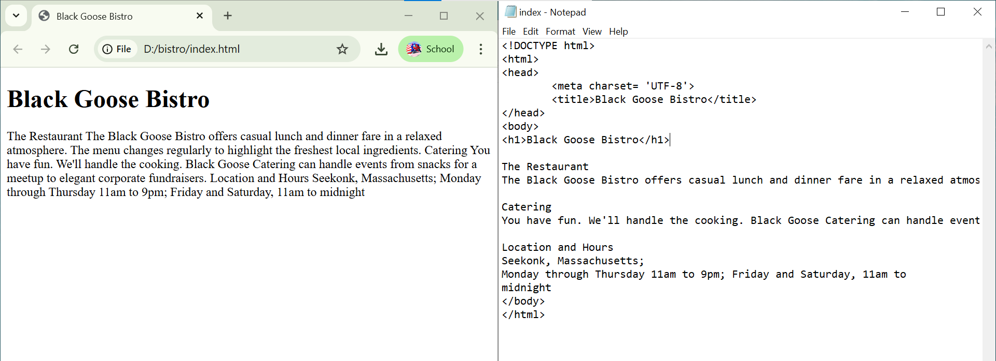
3. Our page also has three subheads. Mark them up as Heading Level 2 (h2) elements in a similar manner. I’ll do the first one here; you do the same for “Catering” and “Location and Hours.”
<h2>The Restaurant</h2>
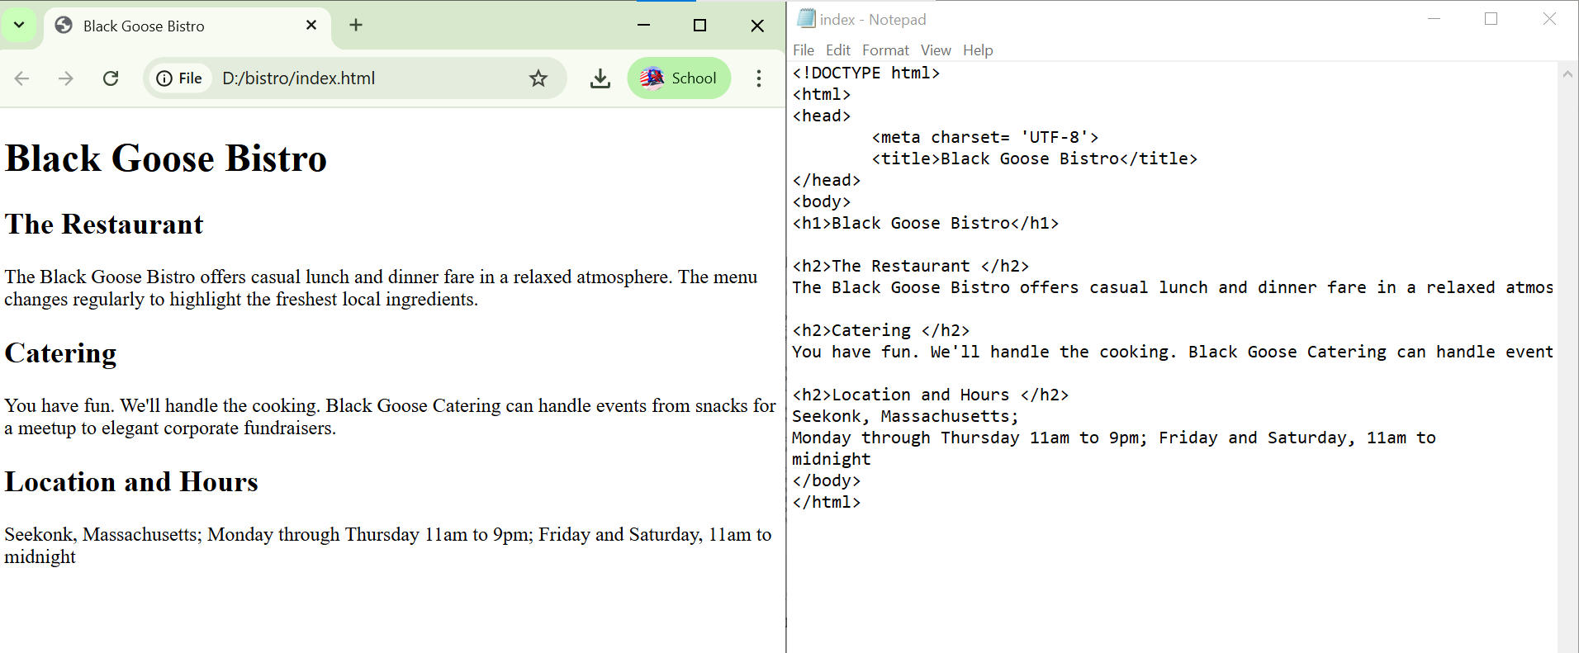
4. Each h2 element is followed by a brief paragraph of text, so let’s mark those up as
paragraph (p) elements in a similar manner. Here’s the first one; you do the rest:
<p>The Black Goose Bistro offers casual lunch and dinner fare in
a relaxed atmosphere. The menu changes regularly to highlight the
freshest local ingredients.</p>
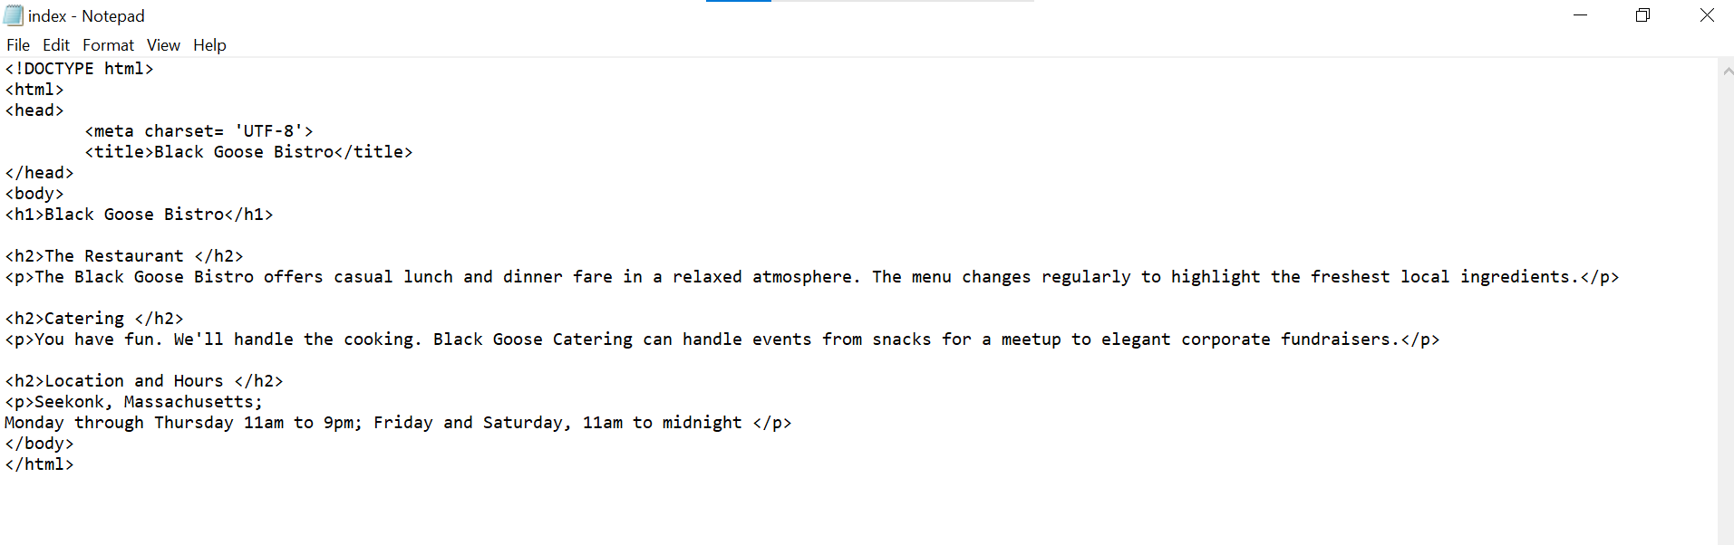
5. Finally, in the Catering section, I want to emphasize that visitors should just leave
the cooking to us. To make text emphasized, mark it up in an emphasis element (em)
element, as shown here:
<p>You have fun. <em>We'll handle the cooking.</em> Black Goose
Catering can handle events from snacks for a meetup to elegant
corporate fundraisers.</p>
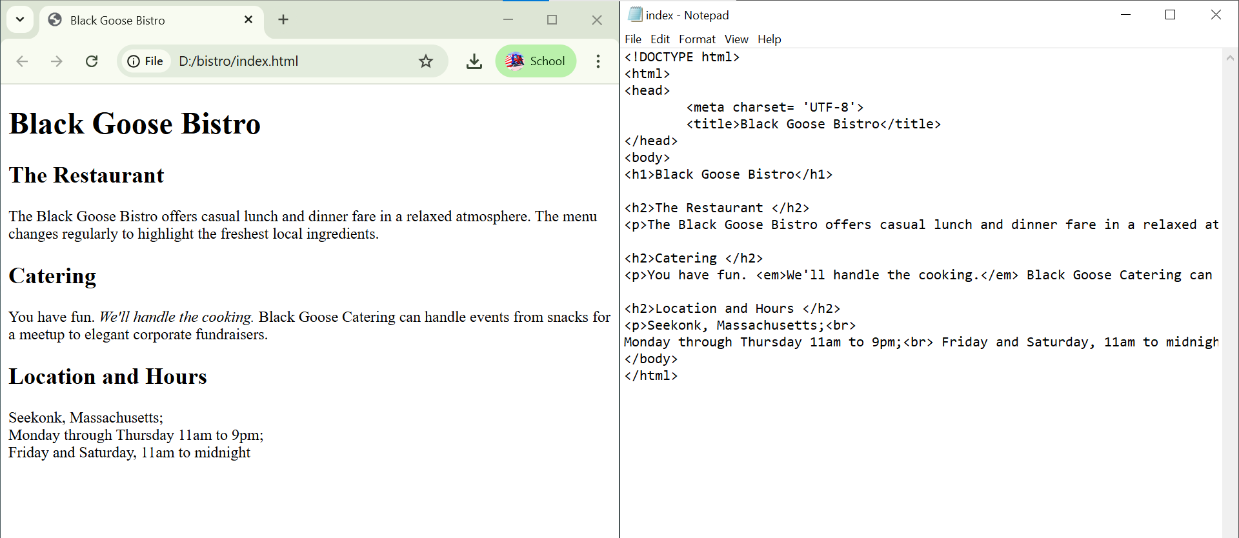
6. Now that we’ve marked up the document, let’s save it as we did before, and open (or reload) the page in the browser. You should see a page that looks much like the one in the following figure. If it doesn’t, check your markup to be sure that you aren’t missing any angle brackets or a slash in a closing tag.
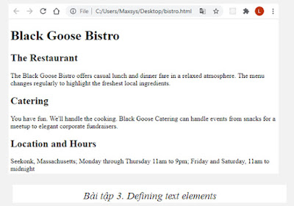
[Kết quả]
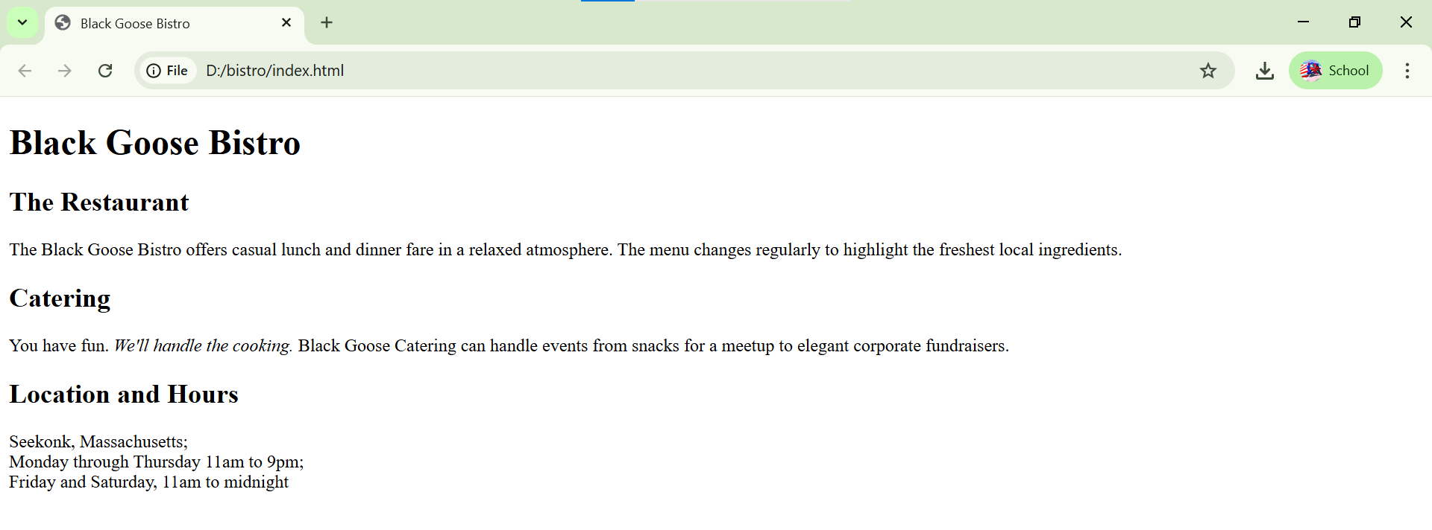

Câu hỏi ôn tập
Câu 1. A static web page (sometimes called a flat page or a stationary page) is a web page that is delivered to the user's web browser exactly as stored, in contrast to __________ which are generated by a web application.
A. dynamic web pages
B. web root
C. Internet
D. database

Câu hỏi 2. Một phần tử HTML (thông thường) gồm các thành phần sau:
A. thẻ mở, thẻ đóng
B. thẻ mở, nội dung
C. thẻ mở, nội dung, thẻ đóng
D. thẻ đóng, nội dung

Câu hỏi 3. Cấu trúc cơ bản của một tài liệu HTML gồm:
A. Phần khai báo (doctype), phần tử html, phần tử head, phần tử title, phần tử body
B. Phần khai báo (doctype), phần tử html, phần tử header, phần tử title, phần tử body
C. Phần khai báo (doctype), phần tử html, phần tử head, phần tử link, phần tử body
D. Phần khai báo (doctype), phần tử html, phần tử p, phần tử title, phần tử body

Câu hỏi 4. Phát biểu nào sau đây là hợp lý:
A. HTML tạo ra cấu trúc và ngữ nghĩa cho phần nội dung trang web
B. HTML thực hiện việc trang trí cho trang web
C. HTML xử lý các tương tác của người dùng trên giao diện web
D. HTML vừa tạo ra phần nội dung vừa thực hiện trang trí cho trang web
Câu hỏi 5. Phát biểu nào đúng khi nói về “<!DOCTYPE html>”?
A. Là một thẻ HTML
B. Là một khai báo trong tài liệu HTML
C. Là một phần tử HTML
D. Là một chú thích trong HTML

